An ISO 9001:2015 Certified Company

Stay Flat Carboard Mailer- Kraft
Product Data Sheet- Effective 09/2018
Product Description:
A premium quality, strong, durable and stiff Kraft (brown) stay flat carboard mailer that resists bending or warping of contents during shipment.
Nominal Values
Thickness: | 28 pts. | 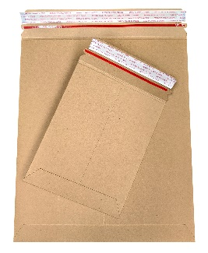
Mailer Color: | Kraft (Brown)
Tape Color: | White with red print
Sealing: | Permanent Adhesive with Tear Tab
Closing Flap Size: | 2”
Item # | Item Description | Outside Dimensions
SFM66KT | Stay Flat Mailer, 6" X 6" Kraft, 200 pcs/case (9) | 6” x 6”
SFM68KT | Stay Flat Mailer, 6" X 8" Kraft, 100 pcs/case (1) | 6” x 8”
SFM79KT | Stay Flat Mailer, 7" X 9" Kraft, 100 pcs/case (10) | 7” x 9”
SFM9115KT | Stay Flat Mailer, 9" X 11.5" Kraft, 100 pcs/case (2) | 9” x 11”
SFM9751225KT | Stay Flat Mailer, 9.75" X 12.25" Kraft, 100 pcs/case (5) | 9.75” x 12.25”
SFM11135KT | Stay Flat Mailer, 11" X 13.5" Kraft, 100 pcs/case (3) | 11” x 13.5”
SFM127515KT | Stay Flat Mailer, 12.75" X 15" Kraft, 100 pcs/case (4) | 12.75” x 15”
SFM1318KT | Stay Flat Mailer, 13" X 18" Kraft, 100 pcs/case (6) | 13” x 18”
Use: Shipping photographs, letters, CD’s, DVD’s, and various types of documents via UPS, USPS, FedEx, DHL and other carriers
We believe the statements and information contained herein are accurate but are to be used only as general guidelines and are not warrants or guarantees because of the variety of possible uses. THERE IS NO WARRANTY OF FITNESS FOR A PARTICULAR PURPOSE. THE BUYER MUST TEST THE SUITABILITY FOR EACH INTENDED APPLICATION BEFORE USING. WRAPTITE WILL NOT BE LIABLE FOR DAMAGES IN EXCESS OF THE PURCHASE PRICE OF ITS PRODUCTS OR FOR INCIDENTAL OR CONSEQUENTIAL DAMAGES.
Wrap Tite, Inc.
6200 Cochran Rd.
Solon, Ohio 44139
Toll Free: 888-WRAP TITE (972-7848)
Fax: 440-349-5432
www.wraptite.com - info@wraptite.com

