An ISO 9001:2015 Certified Company

Poly Bubble Mailer
Product Data Sheet- Effective 07/2018
Product Description:
Made from 100% Polyethylene (PE) film, Poly Bubble Mailers have been designed to withstand the rigors of the mailing industry while providing an alternate and economical solution to shipping v/s boxes. The bubble provides cushioning while the PE liner is water, puncture and tear resistant.
Nominal Values
Thickness of PE Film | 65 microns | 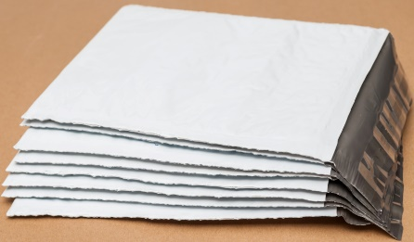
PE Film color | White Outside / Grey Inside
Tape Color | Clear/White Anti-static
Tape Width | 0.75”
Lip Width | 1.57”
Bubble height | 1/8” or 3/16” - 2 layers
Sealing Strip Adhesive | Permanent
Item # | Item Description | Inner Usable Size (Inches)
PBM79 | 7.25 x 9.75, Poly Bubble Mailer, 100/cs, DVD | 7.25 x 8.75
PBM48 | 4 X 8, Poly Bubble Mailer, 500/cs, #000 | 4 x 7
PBM510 | 5x10, Poly Bubble Mailer, 250/cs, #00 | 5 x 9
PBM6585 | 6.5 x 8.5, Poly Bubble Mailer, 250/cs, #CD | 7.25 x 7.0
PBM610 | 6.5 x10 Poly Bubble Mailer, 250/cs, #0 | 6.5 x 9
PBM72512 | 7.25x12, Poly Bubble Mailer, 100/cs, #1 | 7.25 x 11
PBM8512 | 8.5x12, Poly Bubble Mailer, 100/cs, #2 | 8.5 x 11
PBM85145 | 8.5x14.5, Poly Bubble Mailer, 100/cs, #3 | 8.5 x 13.5
PBM95145 | 9.5x14.5, Poly Bubble Mailer, 100/cs, #4 | 9.5 x 13.5
PBM10516 | 10.5x16, Poly Bubble Mailer, 100/cs, #5 | 10.5 x 15
PBM12519 | 12.5x19, Poly Bubble Mailer, 50/cs, #6 | 12.5 x 18
PBM142520 | 14.25x20, Poly Bubble Mailer, 50/cs, #7 | 14.25 x 19
Use: Shipping products or documents via UPS, USPS, FedEx, DHL and other carriers
We believe the statements and information contained herein are accurate but are to be used only as general guidelines and are not warrants or guarantees because of the variety of possible uses. THERE IS NO WARRANTY OF FITNESS FOR A PARTICULAR PURPOSE. THE BUYER MUST TEST THE SUITABILITY FOR EACH INTENDED APPLICATION BEFORE USING. WRAPTITE WILL NOT BE LIABLE FOR DAMAGES IN EXCESS OF THE PURCHASE PRICE OF ITS PRODUCTS OR FOR INCIDENTAL OR CONSEQUENTIAL DAMAGES.
Wrap Tite, Inc.
6200 Cochran Rd.
Solon, Ohio 44139
Toll Free: 888-WRAP TITE (972-7848)
Fax: 440-349-5432
www.wraptite.com - info@wraptite.com

