An ISO 9001:2015 Certified Company

Kraft Bubble Mailer
Product Data Sheet- Effective 07/2018
Product Description:
A strong, lightweight Kraft paper mailer with a 1/8” or 3/16” bubble lining. These Kraft Bubble Mailers provide outstanding low-cost shipping protection for a wide variety of products
Nominal Values
Kraft paper weight | 110 GSM | 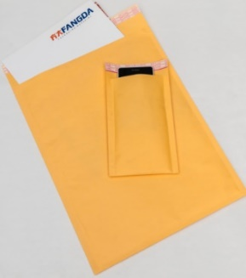
Kraft color | Yellow
Tape Color | White with red/black print
Tape Width | 0.75”
Lip Width | 1.57”
Bubble height | 1/8” or 3/16” - 2 layers
Sealing Strip Adhesive | Permanent
Item # | Item Description | Inner Usable Size (Inches)
KBM79 | 7.25 x 9.75, Kraft Bubble Mailer, 100/cs, DVD | 7.25 x 8.75
KBM48 | 4 X 8, Kraft Bubble Mailer, 500/cs, #000 | 4 x 7
KBM510 | 5x10, Kraft Bubble Mailer, 250/cs, #00 | 5 x 9
KBM6585 | 6.5 x 8.5, Kraft Bubble Mailer, 250/cs, #CD | 7.25 x 7.0
KBM610 | 6.5 x10 Kraft Bubble Mailer, 250/cs, #0 | 6.5 x 9
KBM72512 | 7.25x12, Kraft Bubble Mailer, 100/cs, #1 | 7.25 x 11
KBM8512 | 8.5x12, Kraft Bubble Mailer, 100/cs, #2 | 8.5 x 11
KBM85145 | 8.5x14.5, Kraft Bubble Mailer, 100/cs, #3 | 8.5 x 13.5
KBM95145 | 9.5x14.5, Kraft Bubble Mailer, 100/cs, #4 | 9.5 x 13.5
KBM10516 | 10.5x16, Kraft Bubble Mailer, 100/cs, #5 | 10.5 x 15
KBM12519 | 12.5x19, Kraft Bubble Mailer, 50/cs, #6 | 12.5 x 18
KBM142520 | 14.25x20, Kraft Bubble Mailer, 50/cs, #7 | 14.25 x 19
Use: Shipping products or documents via UPS, USPS, FedEx, DHL and other carriers
We believe the statements and information contained herein are accurate but are to be used only as general guidelines and are not warrants or guarantees because of the variety of possible uses. THERE IS NO WARRANTY OF FITNESS FOR A PARTICULAR PURPOSE. THE BUYER MUST TEST THE SUITABILITY FOR EACH INTENDED APPLICATION BEFORE USING. WRAPTITE WILL NOT BE LIABLE FOR DAMAGES IN EXCESS OF THE PURCHASE PRICE OF ITS PRODUCTS OR FOR INCIDENTAL OR CONSEQUENTIAL DAMAGES.
Wrap Tite, Inc.
6200 Cochran Rd.
Solon, Ohio 44139
Toll Free: 888-WRAP TITE (972-7848)
Fax: 440-349-5432
www.wraptite.com - info@wraptite.com

